
UNIVERSITY INSTITUTE OF COMPUTING

INDIVIDUAL CASE STUDY
ON
CINEBOOK — MOVIE TICKET BOOKING SYSTEM
Object orented program

SUBMITTED BY:
Name | Varun Parmar
UID | 25BCD10122
Branch | BCA (DS)
Section | 25BCD2(B)
Semester | 3

SUBMITTED TO:
Name | Mr. Jitendra Kumar
Designation | Assistant Professor
Date of Submission | 01/11/2026

Table of Contents
- Abstract
- Introduction
- Problem Statement
- Objectives
- Scope and Assumptions
- Requirements Analysis
- System Design
- Object-Oriented Programming Concepts
- Interface Screenshots and Explanation
- Testing Strategy and Test Cases
- Limitations and Future Scope
- Conclusion
- References

Abstract
CineBook is a movie-ticket booking interface concept designed to demonstrate a clear, step-by-step cinema booking journey. The interface presents a catalogue of four sample movies, lets a user choose a showtime, select seats from a visual seat grid, review a booking summary, enter a customer name, and view a booking-confirmation receipt.
This case study documents the user interface shown in the supplied screenshots, its intended workflow, proposed software requirements, high-level design, object-oriented programming (OOP) mapping, and a practical test plan. The screenshots provide evidence of the displayed interface and one example booking flow. They do not, by themselves, prove that a C++/Qt backend, persistent storage, payment integration, or concurrent double-booking protection has been completed. Those items are therefore described as design goals or future validation tasks where appropriate.

1. Introduction
Online ticket booking systems allow customers to browse entertainment options and reserve seats without visiting a physical counter. A well-designed booking interface should make the main steps easy to understand, show the price before confirmation, and communicate the result clearly.
CineBook is a dark-themed movie ticket booking prototype with a black background, red highlights, movie cards, showtime controls, a seat-selection grid, a booking summary, and a confirmation panel. The screenshots show sample movie titles and prices: Midnight Protocol ($12.00), The Last Horizon ($10.00), Crimson Echo ($11.00), and Paper Moons ($9.00). These are demonstration values rather than real cinema listings or live prices.
The purpose of this case study is to analyse the interface and explain how the system could be structured as an object-oriented application. The current evidence is visual: the supplied screenshots show the interface states. The report does not claim that a native C++ executable or database has been independently run or verified.

2. Problem Statement
Manual ticket booking can involve queues, repeated communication about showtimes, uncertainty about seat availability, and errors when calculating the total price. A digital booking workflow can make these tasks easier by presenting the movie, showtime, seats, and total in one place.
Problem addressed: design a clear booking workflow that allows a user to select a movie and showtime, choose one or more seats, see the calculated total, provide a customer name, and receive a confirmation summary. The system should also be designed to prevent duplicate reservations for the same seat and showtime.

3. Objectives
• Present movie choices with titles, genres, and sample ticket prices.
• Let users select a showtime for the chosen movie.
• Display seats in a labelled grid and distinguish available, selected, and booked states.
• Show the selected seats, ticket count, and total price in a booking summary.
• Collect the customer's name before allowing confirmation.
• Display a confirmation receipt with movie, guest, showtime, seats, total, and booking ID.
• Apply OOP principles to separate movie, seat, show, customer, ticket, and booking responsibilities.
• Define tests for validation, pricing, seat-state handling, and duplicate-booking prevention.

4. Scope and Assumptions
Included in the demonstrated interface: movie selection, showtime selection, seat grid, live-looking booking summary, customer-name field, confirmation state, and a sample booking ID.
Assumptions for the proposed implementation: ticket prices are stored in the movie/show data; seat availability belongs to a specific showtime; a booking is valid only when at least one available seat is selected and a customer name is supplied; totals equal ticket price multiplied by the number of seats unless a future pricing rule is introduced.
Out of scope for the supplied evidence: real payment processing, real cinema inventory, account login, online server synchronisation, production security, and verified persistent storage.

5. Requirements Analysis

5.1 Functional requirements
FR-1: Display the available sample movies and their genres/prices. FR-2: Allow selection of a movie. FR-3: Display showtimes and allow one to be selected. FR-4: Display a seat grid. FR-5: Allow selection and deselection of available seats. FR-6: Update selected-seat count and total price. FR-7: Require a customer name and at least one seat before confirmation. FR-8: Generate and display a booking reference. FR-9: Show a list of previous bookings if the My bookings view is implemented. FR-10: Reject seats already booked for the same show.

5.2 Non-functional requirements
Usability: labels and controls should make each step obvious. Consistency: use the same visual language throughout the flow. Responsiveness: layout should remain usable at common desktop window sizes. Reliability: price and seat-state calculations should be consistent. Maintainability: keep interface, domain model, and booking logic separate. Security: validate user input and avoid trusting client-side state for real bookings. Accessibility: provide readable contrast, keyboard focus, and non-colour indicators for seat states.

5.3 Suggested tools and technologies
The screenshots show a web-style interface, but they do not establish the exact technology used to build it. For a native college implementation, the planned stack can be C++ with Qt 6 Widgets or Qt Quick for the GUI, standard C++ classes for business logic, and JSON or a small database for local demonstration data. The actual final stack should be stated only after the implementation files are confirmed.

6. System Design

6.1 High-level workflow
1. Open CineBook. 2. Browse and choose a movie. 3. Choose a showtime. 4. Select one or more available seats. 5. Review seats, ticket count, and total. 6. Enter the customer's name. 7. Validate the booking request. 8. Mark seats as booked and create a booking reference. 9. Display the confirmation receipt.

6.2 Main modules
Movie Catalogue: stores the movie title, genre, and base price. Showtime Manager: associates a movie with one or more showtimes. Seat Manager: tracks seat labels and availability for a show. Booking Summary: calculates ticket count and total. Booking Service: validates and confirms a reservation. Receipt View: displays booking details. My Bookings: an intended view for reviewing prior bookings, subject to implementation.

6.3 Proposed data model
Movie: movieId, title, genre, ticketPrice. Show: showId, movieId, time, seatCollection. Seat: seatId, row, number, status. Customer: customerId, name. Booking: bookingId, customer, show, selectedSeats, total, status. Ticket: common ticket abstraction, with concrete ticket types if pricing policies differ.

6.4 Price calculation
Total = ticket price × number of selected seats. For example, one seat for Midnight Protocol at the displayed sample price of $12.00 gives a total of $12.00. If three seats were selected at the same price, the expected total would be $36.00 before any optional fees or discounts.

7. Object-Oriented Programming Concepts
Classes and objects: Movie, Seat, Show, Customer, Booking, and Ticket can model the core entities. Each object contains the data and operations relevant to its role.
Encapsulation: seat status and booking details should be private, with controlled methods such as selectSeat(), releaseSeat(), and confirmBooking() so invalid state changes can be rejected.
Abstraction: a BookingService can expose a simple confirmBooking() operation while hiding validation, total calculation, booking-ID creation, and persistence details.
Inheritance: an abstract Ticket base class can define common ticket operations, with derived ticket types such as StandardTicket or PremiumTicket if the project supports different ticket categories.
Polymorphism: virtual methods such as calculatePrice() can be implemented differently by derived ticket types. This is a proposed design mapping; the screenshots alone cannot prove that runtime polymorphism is present in the underlying code.
Composition: a Booking can contain a Customer reference, a Show reference, a collection of selected Seat identifiers, and ticket details. A Show can own or manage its seats.
Exception handling: booking operations should handle invalid input, empty seat selection, unavailable seats, invalid showtime, and persistence failures using exceptions or explicit error results. The interface should show a clear message rather than crash.
Separation of concerns: the GUI should collect input and render state; domain classes should represent the cinema data; a service layer should apply booking rules. This separation makes the application easier to test.

8. Interface Screenshots and Explanation
Note: the booking ID and displayed booking state are evidence of the shown prototype screen only. They do not prove that a unique identifier was generated securely, that the reservation survives application restart, or that another user is prevented from selecting the same seat.
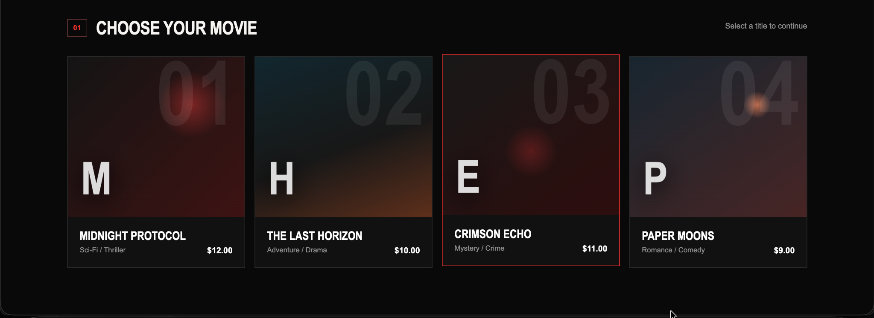
Figure 1. CineBook movie catalogue with four sample titles, genres, and prices.
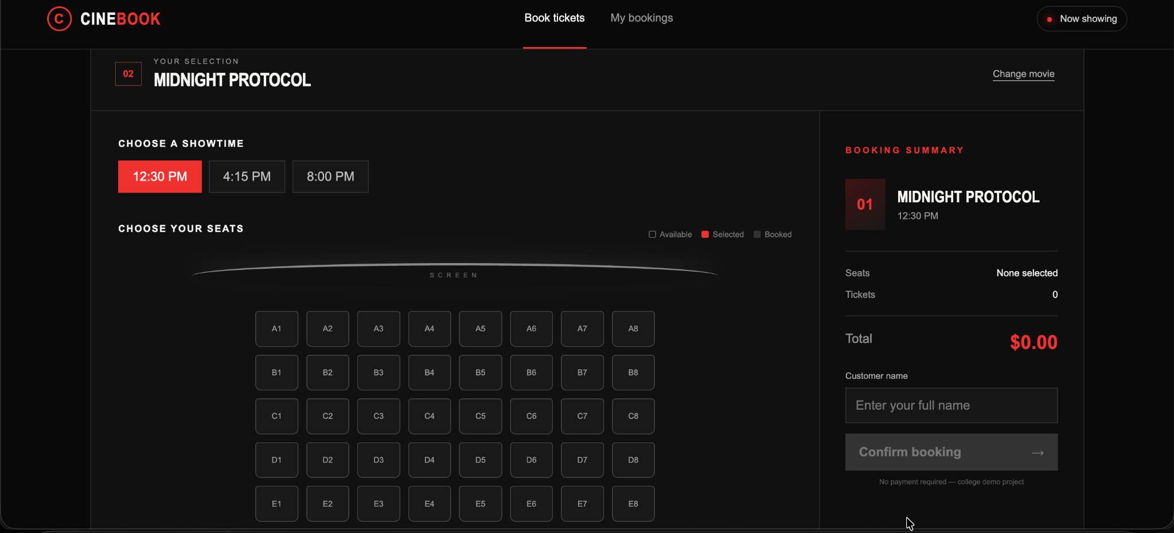
Figure 2. Showtime selection, seat grid, and booking summary before seat selection.
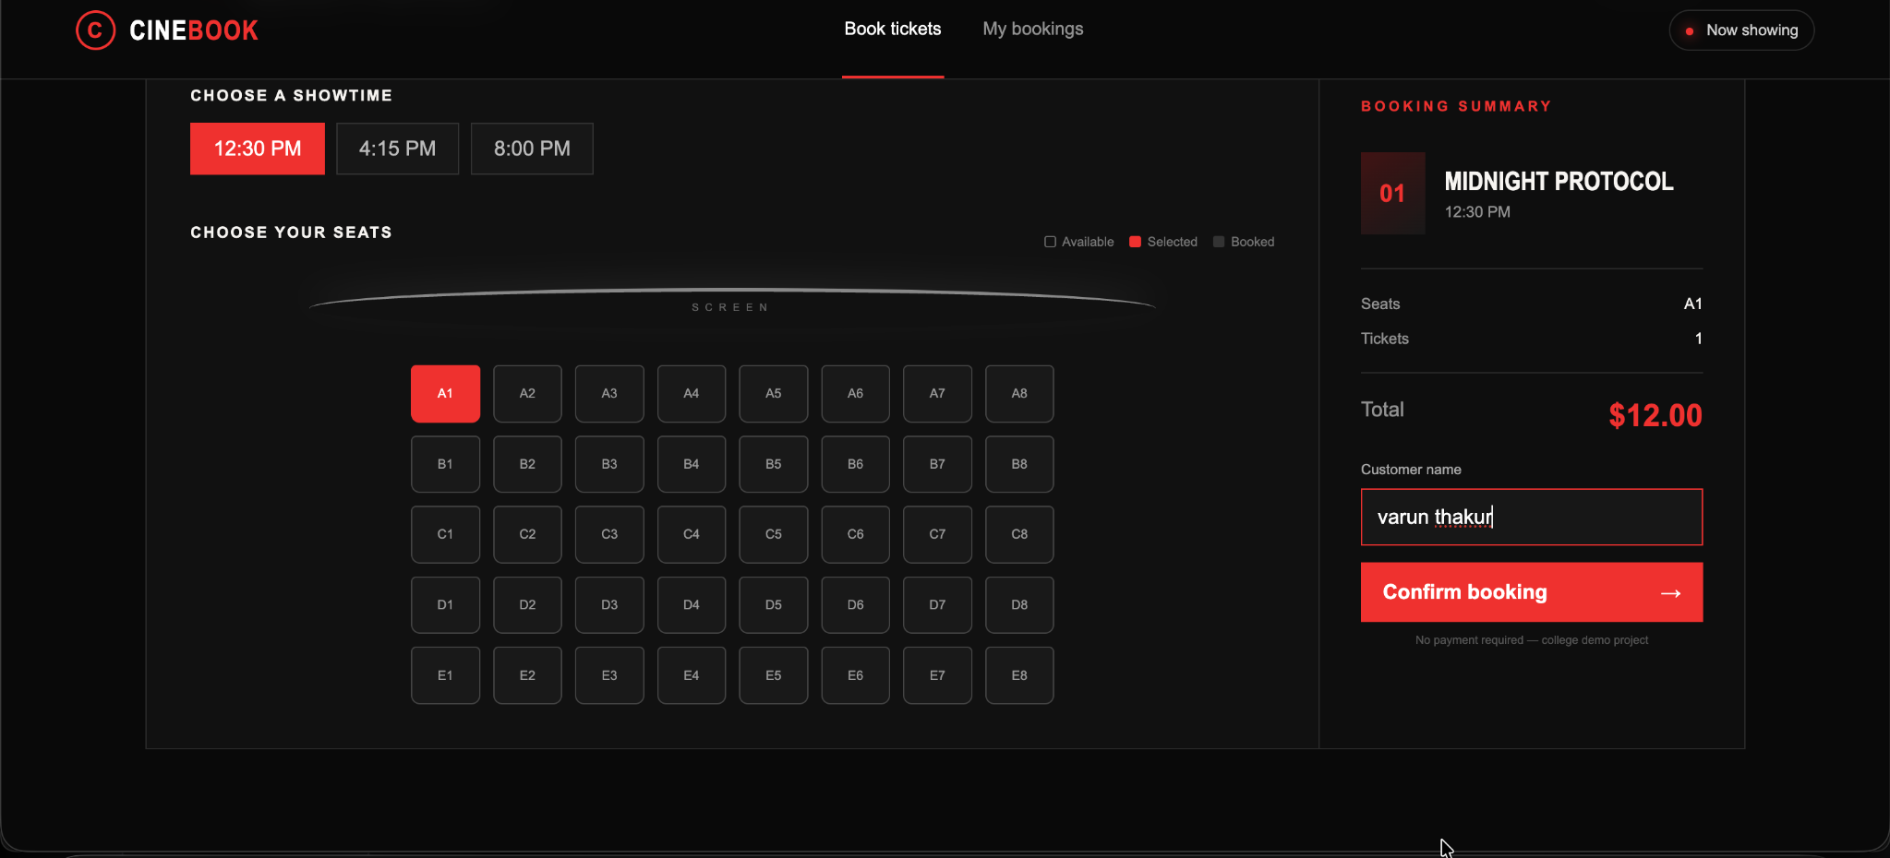
Figure 3. Seat A1 selected; ticket count and total updated; customer name entered.
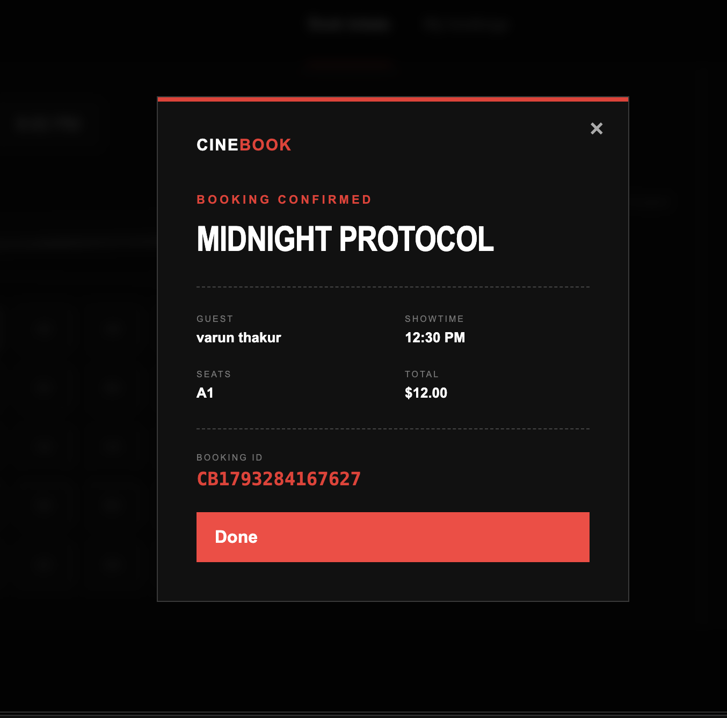
Figure 4. Booking confirmation panel showing guest, showtime, seat, total, and booking reference.

9. Testing Strategy and Test Cases
Testing should be performed against the completed application build. Since only interface screenshots were supplied, the table below is a proposed test plan, not a claim that every test has already passed.
TC-01 Movie catalogue: open the first screen; expected result is that all configured movies, genres, and prices are visible.
TC-02 Movie selection: select each movie card; expected result is that the chosen movie is clearly highlighted and carried to the booking view.
TC-03 Showtime selection: choose each available showtime; expected result is that the active time is highlighted and included in the summary.
TC-04 No seat selected: attempt confirmation with zero seats; expected result is that confirmation is blocked and a helpful message is shown.
TC-05 Seat selection: select A1; expected result is that the seat becomes selected and the ticket count and total update.
TC-06 Seat deselection: click a selected seat again; expected result is that it becomes available in the selection and the total decreases accordingly.
TC-07 Multiple seats: select two or more seats; expected result is that the total equals price × seat count.
TC-08 Customer validation: leave the name blank and confirm; expected result is that the request is rejected.
TC-09 Successful booking: enter a valid name and select an available seat; expected result is that a confirmation summary is displayed.
TC-10 Duplicate seat booking: attempt to reserve the same seat twice for the same show; expected result is that the second request is rejected by the booking logic.
TC-11 Persistence: confirm a booking, restart the app, and inspect bookings; expected result is that data remains only if persistence has been implemented.
TC-12 Invalid data/error handling: supply invalid input or simulate a storage failure; expected result is a clear error response without application failure.
Status: the supplied screenshots visually support the interface states shown in Figures 1–4. The remaining cases require execution and verification against the actual project build.
ID | Test | Expected result | Evidence/status
TC-01 | Movie catalogue | Four sample movie cards visible | Shown in screenshot
TC-02 | Movie selection | Selected movie highlighted | Shown in screenshots
TC-03 | Showtime selection | Active time highlighted | Shown in screenshots
TC-04 | No seats selected | Confirmation blocked | Not verified
TC-05 | Select seat A1 | Count 1; total $12.00 | Shown in screenshot
TC-06 | Deselect seat | Count and total decrease | Not verified
TC-07 | Select multiple seats | Total scales with count | Not verified
TC-08 | Blank customer name | Validation message | Not verified
TC-09 | Confirm valid booking | Receipt appears | Receipt screen shown
TC-10 | Duplicate seat booking | Second booking rejected | Not verified
TC-11 | Restart/persistence | Booking retained if implemented | Not verified
TC-12 | Invalid input/storage error | Handled safely | Not verified

10. Limitations and Future Scope
Limitations of the current evidence: the screenshots do not include source code, a build log, a test report, or database evidence. The interface appears to use sample titles, sample prices, and a demo booking message. It should not be described as a production-ready or payment-enabled service.
Future improvements: connect the interface to a verified C++/Qt application; store bookings locally or in a database; implement show-specific seat locking and duplicate-booking checks; add user-friendly validation; support ticket categories, discounts, taxes, and currency configuration; add printable receipts; implement a functional My bookings view; improve keyboard navigation and accessibility; and run the test cases on the final build.

11. Conclusion
CineBook demonstrates a structured and visually consistent movie-ticket booking journey. The supplied screens cover the main user-facing stages: choosing a movie, choosing a showtime, selecting a seat, reviewing a total, entering a customer name, and viewing a confirmation receipt.
The case study also outlines how the system can be organised using object-oriented design. Classes, encapsulation, abstraction, inheritance, polymorphism, composition, and exception handling can help separate responsibilities and protect booking rules. The next step is to connect the demonstrated interface to a verified C++/Qt implementation and execute the proposed test plan before claiming full functionality.

12. References
1. Qt Documentation, “Qt 6 Documentation,” https://doc.qt.io/qt-6/ (consulted as a suggested reference for a potential Qt implementation).
2. ISO/IEC/IEEE 29148, Systems and software engineering — Life cycle processes — Requirements engineering (requirements-writing reference).
3. ISO/IEC/IEEE 29119, Software Testing (software test process reference).
4. Object Management Group, UML specifications and resources, https://www.omg.org/spec/UML/ (high-level system modelling reference).
5. User-supplied CineBook interface screenshots, dated 29 October 2026, used as visual evidence for the interface analysis.

13.coding an technical writing

1. Project folder structure
CineBook/
├── Makefile
├── include/
│ ├── Models.h
│ └── Cinema.h
├── src/
│ ├── main.cpp
│ ├── Models.cpp
│ └── Cinema.cpp
├── public/
│ └── cinebook/
│ ├── index.html
│ ├── styles.css
│ └── app.js
├── tests/
│ └── test_cinema.cpp
└── data/

include/Models.h:
#pragma once

#include <string>
#include <vector>

class Movie {
private:
int id_;
std::string title_;
std::string genre_;
double price_;

public:
Movie(int id, std::string title,
std::string genre, double price);

int getId() const;
const std::string& getTitle() const;
const std::string& getGenre() const;
double getPrice() const;
};

class Seat {
private:
std::string label_;
bool booked_;

public:
explicit Seat(std::string label, bool booked = false);

const std::string& getLabel() const;
bool isBooked() const;
void setBooked(bool booked);
};

class Customer {
private:
std::string name_;

public:
explicit Customer(std::string name);

const std::string& getName() const;
};

class Show {
private:
int id_;
int movieId_;
std::string time_;
std::vector<Seat> seats_;

public:
Show(int id, int movieId, std::string time);

int getId() const;
int getMovieId() const;
const std::string& getTime() const;
const std::vector<Seat>& getSeats() const;
bool hasSeat(const std::string& label) const;
};

class Ticket {
public:
virtual ~Ticket() = default;

virtual double calculatePrice(
double basePrice, int quantity
) const = 0;

virtual std::string type() const = 0;
};

class RegularTicket : public Ticket {
public:
double calculatePrice(
double basePrice, int quantity
) const override;

std::string type() const override;
};

class Booking {
private:
std::string id_;
Customer customer_;
int movieId_;
int showId_;
std::string movieTitle_;
std::string showTime_;
std::vector<std::string> seatLabels_;
double total_;
bool active_;

public:
Booking(
std::string id,
Customer customer,
int movieId,
int showId,
std::string movieTitle,
std::string showTime,
std::vector<std::string> seatLabels,
double total,
bool active = true
);

const std::string& getId() const;
const Customer& getCustomer() const;
int getMovieId() const;
int getShowId() const;
const std::string& getMovieTitle() const;
const std::string& getShowTime() const;
const std::vector<std::string>& getSeatLabels() const;
double getTotal() const;
bool isActive() const;

void cancel();
};

include/Cinema.h:
#pragma once

#include "Models.h"

#include <stdexcept>
#include <string>
#include <vector>

class BookingException : public std::runtime_error {
public:
using std::runtime_error::runtime_error;
};

class Cinema {
private:
std::vector<Movie> movies_;
std::vector<Show> shows_;
std::vector<Booking> bookings_;
std::string dataFile_;

const Movie& findMovie(int movieId) const;
const Show& findShow(int showId) const;

void saveBookings() const;
void loadBookings();

std::string makeBookingId() const;

public:
explicit Cinema(
std::string dataFile = "data/bookings.txt"
);

const std::vector<Movie>& getMovies() const;
const std::vector<Show>& getShows() const;
const std::vector<Booking>& getBookings() const;

std::vector<std::string> getBookedSeats(int showId) const;

Booking createBooking(
const std::string& customerName,
int movieId,
int showId,
const std::vector<std::string>& seats
);

void cancelBooking(const std::string& bookingId);

std::string moviesJson() const;
std::string seatsJson(int showId) const;
std::string bookingsJson() const;

static std::string bookingJson(const Booking& booking);
};

src/Models.cpp:
#include "Models.h"

#include <algorithm>
#include <utility>

Movie::Movie(
int id,
std::string title,
std::string genre,
double price
) : id_(id),
title_(std::move(title)),
genre_(std::move(genre)),
price_(price) {}

int Movie::getId() const {
return id_;
}

const std::string& Movie::getTitle() const {
return title_;
}

const std::string& Movie::getGenre() const {
return genre_;
}

double Movie::getPrice() const {
return price_;
}

Seat::Seat(std::string label, bool booked)
: label_(std::move(label)), booked_(booked) {}

const std::string& Seat::getLabel() const {
return label_;
}

bool Seat::isBooked() const {
return booked_;
}

void Seat::setBooked(bool booked) {
booked_ = booked;
}

Customer::Customer(std::string name)
: name_(std::move(name)) {}

const std::string& Customer::getName() const {
return name_;
}

Show::Show(int id, int movieId, std::string time)
: id_(id),
movieId_(movieId),
time_(std::move(time)) {

for (char row = 'A'; row <= 'E'; ++row) {
for (int number = 1; number <= 8; ++number) {
seats_.emplace_back(
std::string(1, row) + std::to_string(number)
);
}
}
}

int Show::getId() const {
return id_;
}

int Show::getMovieId() const {
return movieId_;
}

const std::string& Show::getTime() const {
return time_;
}

const std::vector<Seat>& Show::getSeats() const {
return seats_;
}

bool Show::hasSeat(const std::string& label) const {
return std::any_of(
seats_.begin(),
seats_.end(),
[&](const Seat& seat) {
return seat.getLabel() == label;
}
);
}

double RegularTicket::calculatePrice(
double basePrice, int quantity
) const {
return basePrice * quantity;
}

std::string RegularTicket::type() const {
return "Regular";
}

Booking::Booking(
std::string id,
Customer customer,
int movieId,
int showId,
std::string movieTitle,
std::string showTime,
std::vector<std::string> seatLabels,
double total,
bool active
) : id_(std::move(id)),
customer_(std::move(customer)),
movieId_(movieId),
showId_(showId),
movieTitle_(std::move(movieTitle)),
showTime_(std::move(showTime)),
seatLabels_(std::move(seatLabels)),
total_(total),
active_(active) {}

const std::string& Booking::getId() const {
return id_;
}

const Customer& Booking::getCustomer() const {
return customer_;
}

int Booking::getMovieId() const {
return movieId_;
}

int Booking::getShowId() const {
return showId_;
}

const std::string& Booking::getMovieTitle() const {
return movieTitle_;
}

const std::string& Booking::getShowTime() const {
return showTime_;
}

const std::vector<std::string>& Booking::getSeatLabels() const {
return seatLabels_;
}

double Booking::getTotal() const {
return total_;
}

bool Booking::isActive() const {
return active_;
}

void Booking::cancel() {
active_ = false;
}

5. src/Cinema.cpp

In this part of coding movie data, booking validation, price calculation, duplicate-seat prevention and the logic of the file are save.
#include "Cinema.h"

#include <algorithm>
#include <chrono>
#include <filesystem>
#include <fstream>
#include <iomanip>
#include <memory>
#include <set>
#include <sstream>
#include <utility>

namespace {

std::vector<std::string> split(
const std::string& text, char delimiter
) {
std::vector<std::string> parts;
std::stringstream stream(text);
std::string part;

while (std::getline(stream, part, delimiter)) {
parts.push_back(part);
}

return parts;
}

std::string join(
const std::vector<std::string>& values,
const std::string& separator
) {
std::ostringstream out;

for (std::size_t i = 0; i < values.size(); ++i) {
if (i) out << separator;
out << values[i];
}

return out.str();
}

std::string jsonEscape(const std::string& value) {
std::ostringstream out;

for (char c : value) {
switch (c) {
case '"': out << "\\\""; break;
case '\\': out << "\\\\"; break;
case '\n': out << "\\n"; break;
case '\r': break;
case '\t': out << "\\t"; break;
default: out << c;
}
}

return out.str();
}

std::string safeField(std::string value) {
for (char& c : value) {
if (c == '|' || c == '\n' || c == '\r') {
c = ' ';
}
}

return value;
}

}

Cinema::Cinema(std::string dataFile)
: dataFile_(std::move(dataFile)) {

movies_ = {
Movie(1, "Midnight Protocol", "Sci-Fi / Thriller", 12.00),
Movie(2, "The Last Horizon", "Adventure / Drama", 10.00),
Movie(3, "Crimson Echo", "Mystery / Crime", 11.00),
Movie(4, "Paper Moons", "Romance / Comedy", 9.00)
};

int showId = 1;

const std::vector<std::string> times = {
"12:30 PM", "4:15 PM", "8:00 PM"
};

for (const Movie& movie : movies_) {
for (const std::string& time : times) {
shows_.emplace_back(
showId++, movie.getId(), time
);
}
}

loadBookings();
}

const std::vector<Movie>& Cinema::getMovies() const {
return movies_;
}

const std::vector<Show>& Cinema::getShows() const {
return shows_;
}

const std::vector<Booking>& Cinema::getBookings() const {
return bookings_;
}

const Movie& Cinema::findMovie(int movieId) const {
auto found = std::find_if(
movies_.begin(), movies_.end(),
[&](const Movie& movie) {
return movie.getId() == movieId;
}
);

if (found == movies_.end()) {
throw BookingException("Movie not found.");
}

return *found;
}

const Show& Cinema::findShow(int showId) const {
auto found = std::find_if(
shows_.begin(), shows_.end(),
[&](const Show& show) {
return show.getId() == showId;
}
);

if (found == shows_.end()) {
throw BookingException("Showtime not found.");
}

return *found;
}

std::vector<std::string> Cinema::getBookedSeats(
int showId
) const {
findShow(showId);

std::vector<std::string> result;

for (const Booking& booking : bookings_) {
if (booking.isActive() && booking.getShowId() == showId) {
result.insert(
result.end(),
booking.getSeatLabels().begin(),
booking.getSeatLabels().end()
);
}
}

return result;
}

Booking Cinema::createBooking(
const std::string& customerName,
int movieId,
int showId,
const std::vector<std::string>& seats
) {
if (customerName.empty()) {
throw BookingException("Customer name is required.");
}

if (seats.empty()) {
throw BookingException("Select at least one seat.");
}

const Movie& movie = findMovie(movieId);
const Show& show = findShow(showId);

if (show.getMovieId() != movieId) {
throw BookingException(
"The showtime does not belong to this movie."
);
}

std::set<std::string> uniqueSeats;

for (const std::string& seat : seats) {
if (!show.hasSeat(seat)) {
throw BookingException("Invalid seat: " + seat);
}

if (!uniqueSeats.insert(seat).second) {
throw BookingException("Duplicate seat selected.");
}
}

const auto booked = getBookedSeats(showId);

for (const std::string& seat : seats) {
if (std::find(booked.begin(), booked.end(), seat)
!= booked.end()) {
throw BookingException(
"Seat " + seat + " is already booked."
);
}
}

std::unique_ptr<Ticket> ticket =
std::make_unique<RegularTicket>();

const double total = ticket->calculatePrice(
movie.getPrice(),
static_cast<int>(seats.size())
);

const auto now = std::chrono::system_clock::now()
.time_since_epoch();

const auto timestamp =
std::chrono::duration_cast<std::chrono::milliseconds>(
now
).count();

const std::string id =
"CB" + std::to_string(timestamp)
+ std::to_string(bookings_.size() % 10);

bookings_.emplace_back(
id,
Customer(safeField(customerName)),
movieId,
showId,
movie.getTitle(),
show.getTime(),
seats,
total
);

saveBookings();

return bookings_.back();
}

void Cinema::cancelBooking(const std::string& bookingId) {
auto found = std::find_if(
bookings_.begin(), bookings_.end(),
[&](const Booking& booking) {
return booking.getId() == bookingId;
}
);

if (found == bookings_.end()) {
throw BookingException("Booking ID not found.");
}

if (!found->isActive()) {
throw BookingException("Booking is already cancelled.");
}

found->cancel();
saveBookings();
}

void Cinema::loadBookings() {
std::ifstream file(dataFile_);
std::string line;

while (std::getline(file, line)) {
const auto fields = split(line, '|');

if (fields.size() != 9) continue;

try {
bookings_.emplace_back(
fields[0],
Customer(fields[1]),
std::stoi(fields[2]),
std::stoi(fields[3]),
fields[4],
fields[5],
split(fields[6], ','),
std::stod(fields[7]),
fields[8] == "1"
);
} catch (...) {
// Ignore malformed records.
}
}
}

void Cinema::saveBookings() const {
const std::filesystem::path path(dataFile_);

if (path.has_parent_path()) {
std::filesystem::create_directories(
path.parent_path()
);
}

std::ofstream file(dataFile_, std::ios::trunc);

if (!file) {
throw BookingException("Could not save booking data.");
}

for (const Booking& booking : bookings_) {
file << safeField(booking.getId()) << '|'
<< safeField(booking.getCustomer().getName()) << '|'
<< booking.getMovieId() << '|'
<< booking.getShowId() << '|'
<< safeField(booking.getMovieTitle()) << '|'
<< safeField(booking.getShowTime()) << '|'
<< join(booking.getSeatLabels(), ",") << '|'
<< std::fixed << std::setprecision(2)
<< booking.getTotal() << '|'
<< (booking.isActive() ? "1" : "0")
<< '\n';
}
}

std::string Cinema::moviesJson() const {
std::ostringstream out;
out << "{\"movies\":[";

for (std::size_t i = 0; i < movies_.size(); ++i) {
const Movie& movie = movies_[i];

if (i) out << ',';

out << "{\"id\":" << movie.getId()
<< ",\"title\":\"" << jsonEscape(movie.getTitle())
<< "\",\"genre\":\"" << jsonEscape(movie.getGenre())
<< "\",\"price\":" << movie.getPrice()
<< ",\"shows\":[";

bool first = true;

for (const Show& show : shows_) {
if (show.getMovieId() != movie.getId()) continue;

if (!first) out << ',';
first = false;

out << "{\"id\":" << show.getId()
<< ",\"time\":\"" << jsonEscape(show.getTime())
<< "\"}";
}

out << "]}";
}

out << "]}";
return out.str();
}

std::string Cinema::seatsJson(int showId) const {
const Show& show = findShow(showId);
const auto booked = getBookedSeats(showId);

std::ostringstream out;
out << "{\"showId\":" << showId << ",\"seats\":[";

for (std::size_t i = 0; i < show.getSeats().size(); ++i) {
if (i) out << ',';

const std::string& label =
show.getSeats()[i].getLabel();

const bool isBooked =
std::find(booked.begin(), booked.end(), label)
!= booked.end();

out << "{\"label\":\"" << label
<< "\",\"booked\":"
<< (isBooked ? "true" : "false") << "}";
}

out << "]}";
return out.str();
}

std::string Cinema::bookingJson(const Booking& booking) {
std::ostringstream out;

out << "{\"id\":\"" << jsonEscape(booking.getId())
<< "\",\"customer\":\""
<< jsonEscape(booking.getCustomer().getName())
<< "\",\"movieId\":" << booking.getMovieId()
<< ",\"showId\":" << booking.getShowId()
<< ",\"movieTitle\":\""
<< jsonEscape(booking.getMovieTitle())
<< "\",\"showTime\":\""
<< jsonEscape(booking.getShowTime())
<< "\",\"seats\":[";

for (std::size_t i = 0;
i < booking.getSeatLabels().size(); ++i) {
if (i) out << ',';

out << "\""
<< jsonEscape(booking.getSeatLabels()[i])
<< "\"";
}

out << "],\"total\":" << booking.getTotal()
<< ",\"active\":"
<< (booking.isActive() ? "true" : "false")
<< "}";

return out.str();
}

std::string Cinema::bookingsJson() const {
std::ostringstream out;
out << "{\"bookings\":[";

for (std::size_t i = 0; i < bookings_.size(); ++i) {
if (i) out << ',';

out << bookingJson(
bookings_[bookings_.size() - 1 - i]
);
}

out << "]}";
return out.str();
}

Makefile:
CXX := g++
CXXFLAGS := -std=c++20 -Wall -Wextra -pedantic -O2 -Iinclude

SOURCES := src/Models.cpp src/Cinema.cpp
TARGET := cinebook

.PHONY: all run test clean

all: $(TARGET)

$(TARGET): $(SOURCES) src/main.cpp
$(CXX) $(CXXFLAGS) $(SOURCES) src/main.cpp -o $(TARGET)

run: $(TARGET)
./$(TARGET)

test: $(SOURCES) tests/test_cinema.cpp
$(CXX) $(CXXFLAGS) $(SOURCES) tests/test_cinema.cpp -o cinebook_tests
./cinebook_tests

clean:
rm -f $(TARGET) cinebook_tests

Github link:https:
https://github.com/parmarvarun902-del/CINEBOOK-MOVIE-TICKET-BOOKING-SYSTEM-Object-orented-program.git

